16 - Simon – African Skies
Original key: Eb Us: D

Entire song: D G | D/A A
Chorus = "this is the story..."

Plan
Intro: six bars melody (bass enters bar 3)
Verse 1: no chords [8 bars]
Chorus 1: chords enter
Instrumental: 4 bars riff
Verse 2: volume pedal chords
Chorus 2: same
Oom-bah-oom-bah with chorus chords 8 bars
Verse 3: 8 bars
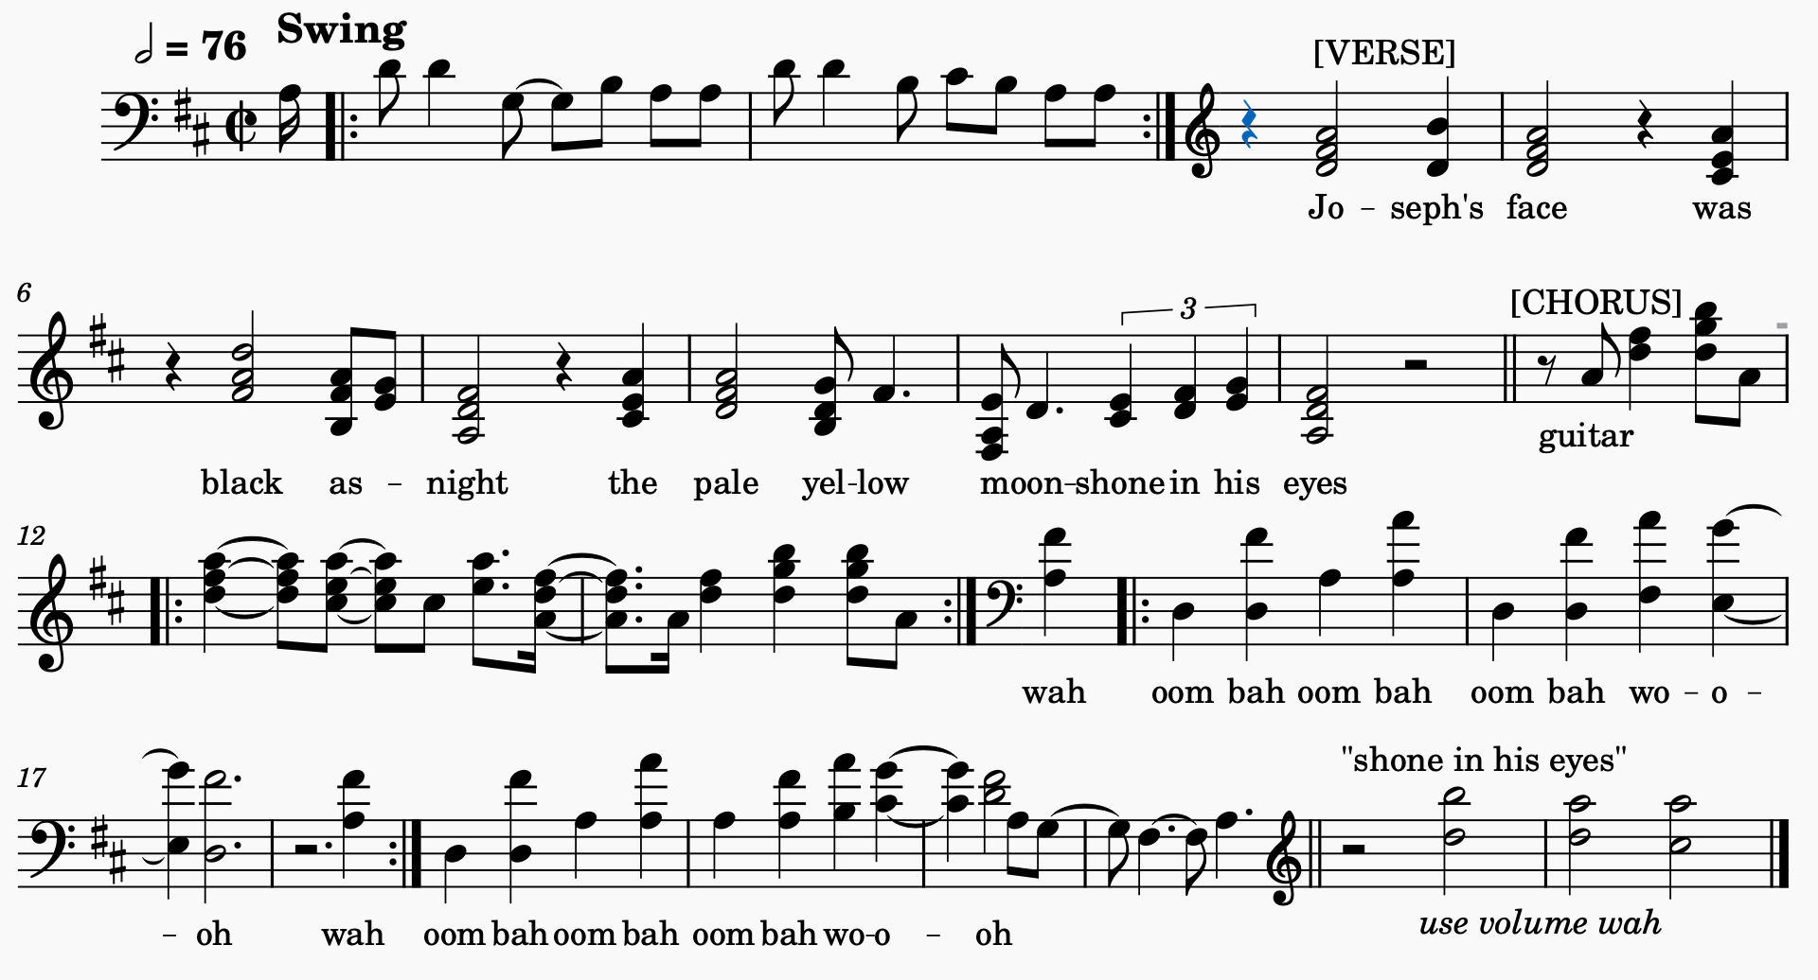
Fade out on riff

